PS3 - Integrated Common Services to Common People

TEAM MEMBERS:

1. GURU PRASATH.K
2. DHAYANITHI.G

TEAM COORDINATORS:

1.DR.ANANDHI (HOD/CS)

2.ARUNACHALAM.G(Asst.prof of CS)

Objective: To develop an integrated digital platform that consolidates various public services, such as healthcare, education, legal aid, and welfare services, into a single accessible interface for common people. This platform aims to streamline access, improve service delivery efficiency, and enhance user experience by leveraging modern technology.

Target Users: General public, including individuals and families, especially those in rural or underserved areas..

* Unified User Account: Single sign-on (SSO) for all services.
* Service Directory: Comprehensive listing of available public services.
* Online Application and Forms: Digital submission and tracking of applications for various services.
* Appointment Scheduling: Integrated calendar to book appointments for healthcare, legal advice, etc.
* Notifications and Alerts: Real-time updates on application status, appointments, and important dates.
* Multilingual Support: Interface available in multiple languages to cater to diverse populations.
* Virtual Assistance: AI-powered chatbots for instant support and guidance.
* Document Management: Secure storage and management of personal documents.
* Feedback and Grievance Redressal: Easy submission of feedback and complaints with tracking features.
* Data Analytics and Reporting: Tools for government bodies to analyze service usage and feedback for continuous improvement.

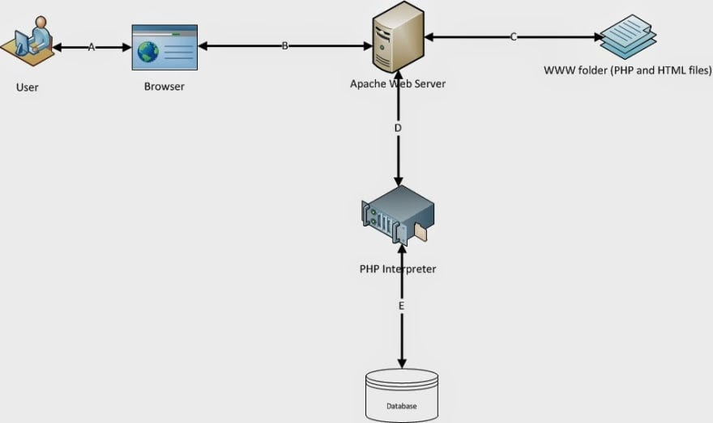

* MYSQL
* PHP

This project is aimed at simplifying access to essential public services for common people. By tourist accommodation services , it not only enhances user convenience but also streamlines service delivery processes for tourist visiting pondicherry. The platform's robust features, including a unified user account, comprehensive service directory, ensure a seamless and efficient user experience. This initiative promises to significantly improve public service accessibility and efficiency, ultimately contributing to betterment for tourism devolepment in Pondicherry city.